Blood Types NAME: ______________________________

1. The FOUR BLOOD TYPES (phenotypes) are: ____ , _____ , _____ and ______.

This means THREE alleles control blood type: A, B, O.

A and B are DOMINANT over O.
A and B together produce an INTERMEDIATE type of inheritance called CO-DOMINANCE.

Genotype | AA | AO | BB | BO | AB | OO
Phenotype | A |  | B |  | AB | O

2. Jeff has blood type A and his wife Jean also has blood type A. Their son, Joey has blood type O. Explain how this is possible – use a punnett square diagram.

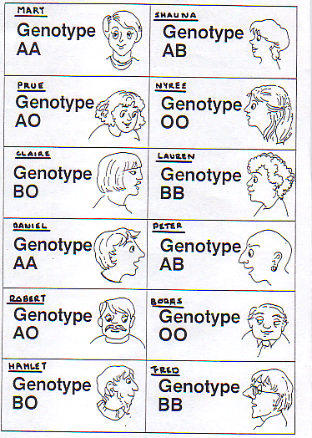
3. Using punnett squares, determine
the blood types of the offspring that result from the following:
- Claire and Fred
- Lauren and Hamlet
- Fred and Nyree
- Mary and Peter

4. If a child has blood group B, give TWO sets of parents that could
produce this child. Explain your answer using punnett square diagrams.

5. Find all the possibilities of who would Mary have to marry to have children that could be type A but NO other type?

BLOOD TRANSFUSIONS:
O blood people are UNIVERSAL DONORS, but can receive only type
O blood.
AB blood people are UNIVERSAL RECIPIENTS, but can only donate
their blood to other AB people.

Other blood groups/types include
(a) Rh factor
(b) M, N groups.

EUGENICS – study of fine human offspring! …to produce a ‘master race’.
George Bernard Shaw – famous philosopher (intelligent but dumpy!)
Isadora Duncan – beautiful ballet dancer, but a bit loopy.
Duncan: Let’s produce the ‘perfect’ baby.
Shaw: What if the baby got my body and your brains!
BLOOD TASK ANSWERS NAME: ___________________________

1. A, B, AB, O

2.

3a. 3b. 3c. 3d.

4. (You may not need all of these Punnett squares

5.

Answers

- A, B, AB, O

 | A | O
A | AA | AO
O | AO | OO

- a. Claire and Fred

 | B | O
B | BB | BO
B | BB | BO

b. Lauren and Hamlet

 | B | O
B | BB | BO
B | BB | BO

c. Fred and Nyree

 | O | O
B | BO | BO
B | BO | BO

d. Mary and Peter

 | A | B
A | AA | AB
A | AA | AB

- Any of the following combinations:

Shauna (AB) & Peter (AB), Robert (AO), Boors (OO), Hamlet (BO) or Fred (BB)
Prue (AO) & Peter (AB), Hamlet (BO) or Fred (BB)
Nyree (OO) & Peter (AB), Hamlet (BO) or Fred (BB)
Claire (BO) & Peter (AB), Robert (AO), Boors (OO), Hamlet (BO) or Fred (BB)
Lauren (BB) & Peter (AB), Robert (AO), Boors (OO), Hamlet (BO) or Fred (BB)

- Daniel (AA x AA), Robert (AA x AO), Boors (AA x OO)

